COMMUNITY INITIATIVES INC.
222 S Riverside Plaza, Suite 380 · Chicago, IL 60606 · www.cicchicago.com

1426 E. Marquette, 60637 - $260,000
For more information or an appointment to view, contact
Sanina Ellison-Jones at chicagohomes@saninaellison.com
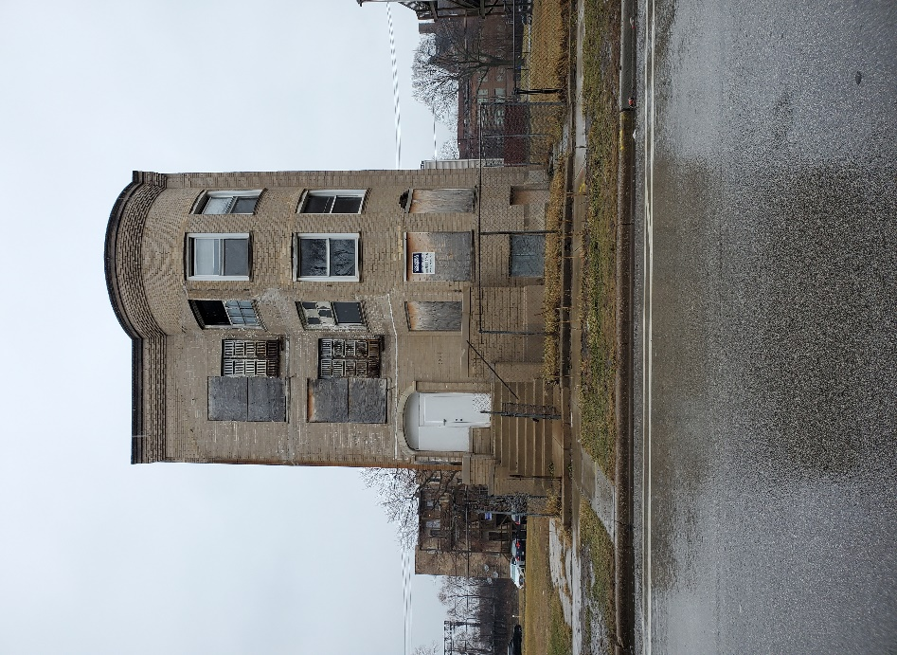 | Vintage 3 -flat in Woodlawn.  Building will require a full rehab!  Possible 6-unit with creativity and other additional requirements  Woodlawn Construction Loan  “As-is” sale and will be prorated at 100%.  All offers will be subject to city approval and a regulatory agreement.  PIN: 20-23-220-020-0000

